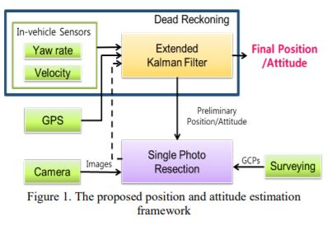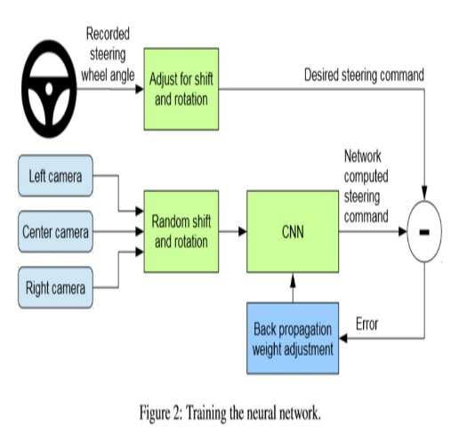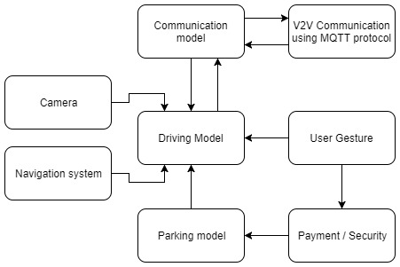

Indian Institute of Technology (BHU) Varanasi

* Driving model using single camera is prepared by mimicking human decision-making approach for efficient and autonomous driving.
* Dataset was recorded while vehicles was driven by human
* A small-scale prototype for driving model was prepared using microprocessor “Raspberry pi” with RTos implemented.
* Basic algorithm has been implemented for PoC.
* It will result in pollution-less environment by introducing Electric Cars.

References

1. Mariusz Bojarski , Davide Del Testa , Daniel Dworakowski , End to End learning for Self-Driving cars , Nvidia.
2. Dean A. Pomerleau. ALVINN, an autonomous land vehicle in a neural network. Technical report, Carnegie Mellon University, 1989.
3. H. Kim , K. Choi, I. Lee ,“IMPROVING CAR NAVIGATION WITH A VISION-BASED SYSTEM”.

Acknowledgement

Corresponding Mentor:

**Dr. NS Rajput (nsrajput.ece@iitbhu.ac.in)**

The financial support, in part, received from the NCC LAB, Department of Electronics Engineering, IIT (BHU), India (Grant no. IS/ST/EC-13- 14/02), from IBM, India (Grant no. R&amp;D/IBM/SBApp/Electronics/15-16/07) and Nvidia, USA for grant of Tesla K 40 GPU under Hardware Support Grant, is gratefully acknowledged.



Tushar Khandelwal , Shreyas Tripathi

Autonomous Navigation of E-Rickshaw using camera.

Dept. of Electronics Engg.



The autonomous cars will play a major role in changing the way society is at current stage. It will play a major role in , reducing human efforts , it holds the key to a better and cleaner transportation ecosystem and a better human experience. Autonomous vehicles aim to achieve reduction inroad congestion, improvement in road design as more cars in seamless coordination with each other can be added onto the same amount of real estate on the road ,safer transportation, and increase mobility. Key_Features- Stakeholders – Academia , Automobile Industry,Public. Social Risks – Acceptance by the public and society , ethical issues evolving in case of accident. Institutional Arrangements – High Computing GPU processor , Different kinds of Sensors ,Avialability of recent softwares.

We will train a convolutional neural network (CNN) to map raw pixels from a single front-facing camera directly to steering commands. This end-to-end approach has been proven surprisingly powerful. With minimum training data from humans the system learns to drive in trafﬁc on local roads with or without lane markings and on highways. Also The real-time acquisition of the accurate positions is very important for the proper operations of driver assistance systems or autonomous vehicles. Since the current systems mostly depend on a GPS and map-matching technique, they show poor and unreliable performance in blockage and weak areas of GPS signals. In this project, we first describe a CNN that goes beyond pattern recognition. It learns the entire processing pipeline needed to steer an automobile and then We will employ a single photo resection process to derive the position and attitude of the camera and thus those of the car and for more accurate estimation of position we use kalman filter. The proposed system estimated the positions with an accuracy of 15 m although GPS signals are not available at all during the entire test drive of 15 minutes and thus helping in building highly accurate and reliable autonomous car.

Motivation and Objectives

**This is the proposal to improve position and altitude estimation to do it better than compared to GPS .**

Target Model

Approach/Methods

Progress made